Product Requirements Document (PRD)

FinTracker – Finance Management App
1/2026
Prepared by Nguyen Ngoc Tuan

Table of contents

I. Product Overview. 3
II. Target Audience. 3
1. Students & Young Professionals. 3
2. Proactive Financial Planners. 3
III. System Flows. 5
II. User Stories & Acceptance. 8

Product Overview.
FinTracker is a comprehensive personal finance management mobile application designed to help users gain complete control over their cash flow.
Built to solve the common pain points of scattered financial tracking and lack of saving discipline, FinTrack provides a centralized platform where users can manage multiple accounting books, record daily transactions, and visualize their spending behavior through intuitive charts. Beyond basic tracking, the application empowers users to build sustainable financial habits through flexible and periodic savings goals, supported by a smart automated notification system.

Target Audience.

Students & Young Professionals.
    - Pain points: Limited income, struggling to track daily micro-expenses, lacking the discipline to save money.
    - Key features used: Basic Transaction Management, Flexible Savings Goals, and Multi-language support for accessibility.

Proactive Financial Planners.
    - Pain points: Managing complex cash flows across different contexts (e.g., personal vs. business/family), missing recurring payments.

    - Key features used: Multiple Book Management (to separate budgeting contexts), Periodic Savings Goals, Recurring Invoices with automated push notifications, and detailed Analytical Charts.

System Flows.
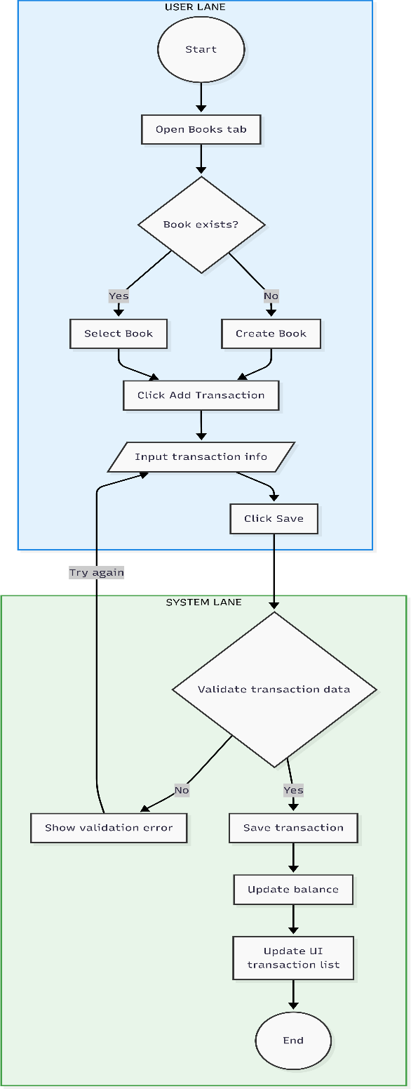

Swimlane diagram separating User actions with transaction management and System background processes.

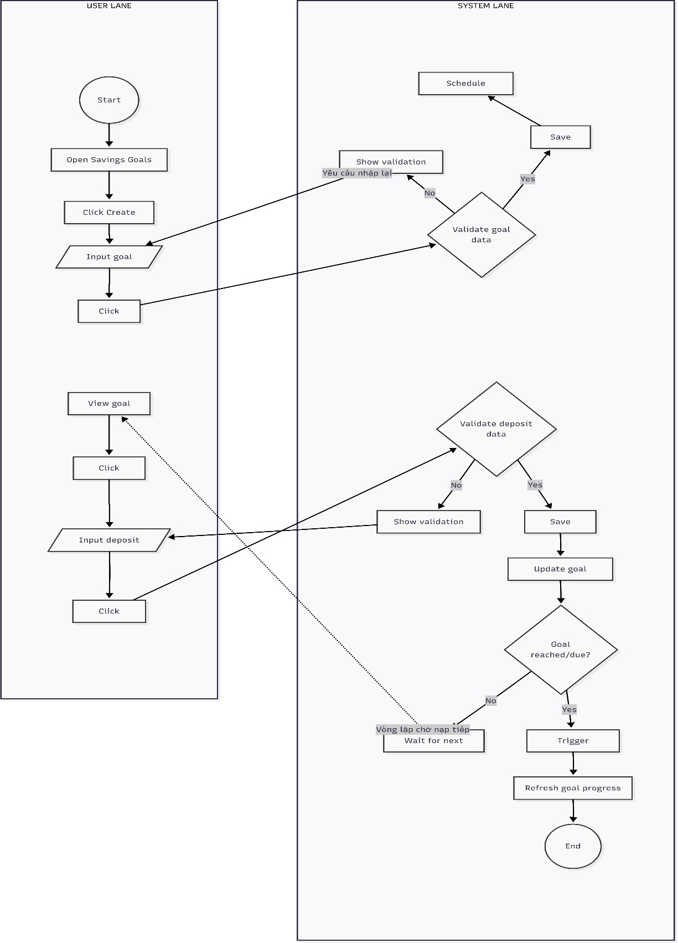
Swimlane diagram separating User actions saving goals and System background processes.

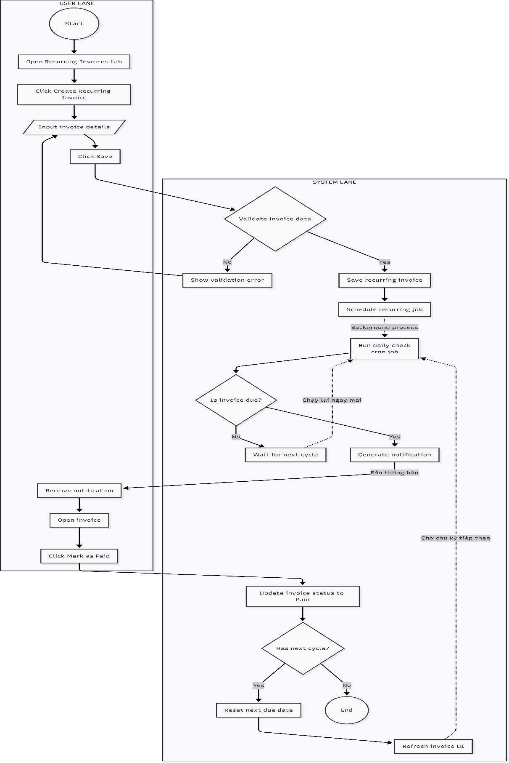
Swimlane diagram separating User actions recuring invoice and System background processes.

II. User Stories & Acceptance.

Feature ID | Feature Name | User Story | Acceptance Criteria | Priority  (MoSCo W)
FNT-01 | Onboarding | As a new user, I want a guided  first-time setup so that I can start  tracking my finances correctly. | - On first launch, onboarding screens are displayed automatically.  - User can navigate through introduction and  accept terms.  - User is required to create at least one book before accessing the main  app. | Should have
FNT-02 | Book  Managemen t | As a user, I want to manage multiple  books so that I can separate different budgeting contexts. | User can create a new book with required information.  User can view a list of books and switch the active book.  User can rename an existing book. | Must have

User can delete a book and system handles
related data according to defined rules.
FNT-03 | Transaction Managemen t | As a user, I want to  record income and expenses so that I can track my  financial activity accurately. | User can create a transaction with amount, type, category, and date.  System validates required fields before saving.  User can edit or delete existing transactions.  Book balance and transaction list update immediately after changes. | Must have
FNT-04 | Analytics | As a user, I want to view  financial analytics so that I can understand my spending behavior and trends. | User can view charts based on selected time range.  Data is filtered by the currently active book. | Must have

Income and expense data are clearly separated or visually distinguished.

System displays a clear empty-state message when no data is available.
FNT-05 | Flexible Savings Goals | As a user, I want to set a custom savings goal so that I can track progress toward a personal objective. | User can create a savings goal with target amount.  User can manually deposit money into the goal.  System updates and displays current progress and remaining amount.  Deposit history is stored and accessible. | Must have
FNT-06 | Periodic Savings Goals | As a user, I want to define periodic  savings so that I can build consistent | User can configure  recurring contribution amount and frequency.  System schedules reminders based on defined frequency. | Must have

 |  | saving habits. | Goal progress updates after each contribution.  System generates notifications for due or completed goals.
FNT-07 | Recurring Invoices | As a user, I want  recurring invoice  reminders so that I can avoid  missing regular payments. | User can create a  recurring invoice with amount, frequency, and due date.  System validates input before saving invoice.  User can mark invoices as paid or unpaid.  System generates notifications for due and  overdue invoices.  User can filter invoices by book, category, or amount. | Must have

FNT-08 | Notification s | As a user, I want a centralized notification inbox so that I can manage all reminders efficiently. | System displays a list of notifications generated from events.  User can mark individual or multiple notifications as read.  User can delete one or multiple notifications.  Notification list updates to reflect the latest state. | Must have
FNT-09 | Settings and Preferences | As a user, I want to customize  app settings so that the app  matches my preferences. | User can change application language.  User can select preferred currency format.  User can switch theme or visual style.  Settings persist after app restart. | Must have
FNT-10 | Authenticati on | As a user, I want to sign in with Google so that I can  securely access and  manage my data. | User can sign in using a Google account.  Session information is stored locally after login.  User can sign out and clear session data. | Must have

System attempts silent login on app startup if session exists.

